Hardee County Library TEEN ROOM Art Contest
The Hardee County Library is partnering with Hardee Arts and Cultural Trust (HACT) to sponsor an art contest celebrating the opening of our new Teen Room!
Winning entries will be proudly displayed in the space for the community to enjoy.

Contest Guidelines
Theme
- All artwork must reflect the theme: Retro Video Games.
- Think classic arcade style, pixel art, and favorite old-school characters and designs.

Eligibility
- Open to Junior High and High School students.
- Each contestant may submit one entry.

Medium & Size
- Any medium is welcome (drawing, painting, digital art, collage, mixed media, etc.).
- Maximum size: 12 inches x 18 inches (portrait or landscape).
- Artwork must be flat and ready for display (no 3D pieces).

Content Requirements
- Entries must be original, age-appropriate, and suitable for public display.
- Artwork should be inspired by retro video game styles rather than reproducing exact designs.
- No offensive, violent, or inappropriate content will be accepted.

Submission
- Entries must be submitted to the Hardee County Library by Friday, February 13th.
- Each entry should include:
  - Artist’s full name
  - Grade level
  - Contact information (phone/email)
- Art work may be turned in to your art teacher or dropped off at the Hardee County Library.

Judging & Awards
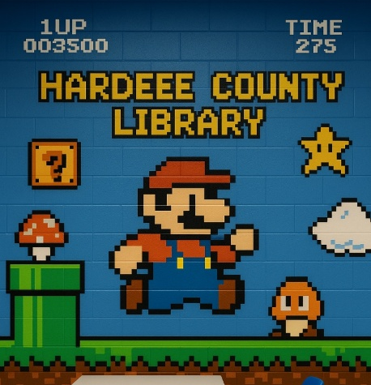
- A panel of judges will evaluate entries based on creativity, connection to theme, originality, and overall presentation.
- Winning entries will be displayed in the new Teen Room.

Other Notes
- By submitting, contestants grant the Hardee County Library permission to display their work and use images of it for promotional purposes.
- All artwork remains the property of the artist and can be retrieved after the display period.

For more info, please contact;
Laura Wells with Hardee Arts and Culture Trust.
Lbwells72@gmail.com / (863)832-1886

